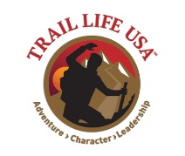
Troop TX-0226
Trail to Freedom Award Trail Badge Plan 2014-15
Adventures Required Trail Badges*

Year | Citizenship | Emergency Preparedness | Family Man | Outdoor Life | Personal Resources | Fitness, Cycling, or Hiking
2014 | Fall | Fall | Fall
2015 |  |  |  | Spring | Spring | Spring

* Plan does not include the Fitness – Swimming Trail Badge as this is best suited for summer camp or time outside of troop meeting or regular campout.

